APTECH LEARNING
E-PROJECT DOCUMENTATION
PULSEFIT
MERN Fitness Web Application & Admin Panel

Submitted By
Subhan — Student1584837
Syed Anas Hussain — Student1594577
Moosa — Student1584888
Kabeer Ahmed — Student1611679
Supervised By
Sir Umar Farooq
Aptech Gulshan E Maymar

CERTIFICATE
This is to certify that the project titled “PulseFit — MERN Fitness Web Application & Admin Panel” has been developed and submitted by Subhan (Student1584837), Syed Anas Hussain (Student1594577), Moosa (Student1584888), and Kabeer Ahmed (Student1611679) as part of the Aptech E-Project at Aptech Gulshan E Maymar under the supervision of Sir Umar Farooq.
The project demonstrates the practical implementation of a full-stack fitness management application using MongoDB, Express.js, React.js, and Node.js, together with supporting technologies for authentication, interface design, data visualization, and database management.
The project has been prepared for academic evaluation and demonstrates the team's understanding of frontend development, backend API development, database integration, authentication, responsive user interfaces, and software project documentation.
Supervisor Signature: ______________________________
Date: ______________________________

DECLARATION
We hereby declare that the project titled “PulseFit — MERN Fitness Web Application & Admin Panel” is our academic project developed as part of the Aptech E-Project. The project has been developed by the team members listed below under the guidance and supervision of Sir Umar Farooq.
- Subhan — Student1584837
- Syed Anas Hussain — Student1594577
- Moosa — Student1584888
- Kabeer Ahmed — Student1611679
This documentation describes the purpose, requirements, design, technologies, modules, database structure, installation procedure, testing, and user interface of the PulseFit application.

ACKNOWLEDGEMENT
We would like to express our sincere gratitude to Aptech Learning, Gulshan E Maymar, for providing us with the opportunity to work on this E-Project. The project gave us practical experience in developing and integrating a complete software application.
We are especially thankful to our supervisor, Sir Umar Farooq, for his guidance, support, and valuable suggestions throughout the project. His guidance helped us understand the project requirements and improve the implementation.
We also appreciate the efforts of all team members who contributed to development, testing, documentation, and completion of the PulseFit application.

ABSTRACT
PulseFit is a modern full-stack fitness web application and administrative portal developed using the MERN stack: MongoDB, Express.js, React.js, and Node.js. The application is designed to provide users with a centralized platform for managing different parts of their fitness journey.
The user application provides an interactive dashboard, workout programs, exercise library, active workout tracking, nutrition and macro tracking, progress and analytics, fitness calculators, notifications, and favorites. The project README describes functionality including daily streaks, calorie targets, water tracking, BMI information, activity charts, workout timers, recipe logging, historical progress, and target heart-rate zones.
PulseFit also provides an administration dashboard for managing users, workout programs, exercises, meals, categories, notifications, and database seeding. MongoDB is used for persistent data storage while Node.js and Express.js provide the backend REST API.
The overall objective of the project is to provide an integrated fitness management environment that combines workout, nutrition, progress, analytics, and administrative functionality within a single application.

TABLE OF CONTENTS
CERTIFICATE 2
DECLARATION 3
ACKNOWLEDGEMENT 4
ABSTRACT 5
TABLE OF CONTENTS 6
LIST OF FIGURES 10
CHAPTER 1 — INTRODUCTION 11
1.1 Background 11
1.2 Project Overview 11
1.3 Purpose of the Project 11
CHAPTER 2 — PROBLEM STATEMENT 12
2.1 Problem Statement 12
CHAPTER 3 — OBJECTIVES 13
3.1 Project Objectives 13
CHAPTER 4 — SCOPE OF THE PROJECT 14
4.1 User Scope 14
4.2 Admin Scope 14
4.3 Project Boundaries 14
CHAPTER 5 — SYSTEM REQUIREMENTS 15
5.1 Functional Requirements 15
5.2 Non-Functional Requirements 16
5.3 Hardware Requirements 16
5.4 Software Requirements 17
CHAPTER 6 — TECHNOLOGIES USED 18
6.1 MERN Stack 18
6.2 MongoDB 18
6.3 Express.js 18
6.4 React.js 18
6.5 Node.js 18
6.6 Tailwind CSS 18
6.7 TypeScript 18
6.8 JWT Authentication 18
6.9 Recharts and UI Libraries 18
CHAPTER 7 — SYSTEM ANALYSIS AND DESIGN 19
7.1 System Architecture 19
7.2 User Roles 19
7.3 System Modules 19
7.4 Database Design 20
7.5 Database Collections 20
CHAPTER 8 — SYSTEM MODULES 21
8.1 Authentication Module 21
8.2 User Dashboard 21
8.3 Workout Module 21
8.4 Exercise Library 21
8.5 Nutrition Module 21
8.6 Progress and Analytics Module 21
8.7 Fitness Calculator Module 21
8.8 Notification Module 21
8.9 Favorites Module 21
8.10 Admin Management Module 22
CHAPTER 9 — USER INTERFACE AND SCREENSHOTS 23
9.1 User Dashboard 24
9.2 Workout Programs 25
9.3 Exercise Library 26
9.4 Nutrition and Recipes 27
9.5 Body Analytics 28
9.6 Workout History 29
9.7 Saved Bookmarks 30
9.8 User Profile 31
CHAPTER 10 — ADMIN PANEL 32
10.1 Admin Dashboard and Analytics 33
10.2 User Management 34
10.3 Workout Programs Management 35
10.4 Exercise Management 36
10.5 Nutrition and Recipes Management 37
10.6 Taxonomy and Category Management 38
10.7 Push Notifications and Broadcasts 39
CHAPTER 11 — AUTHENTICATION AND USER SETUP 40
11.1 Authentication Interface 41
11.2 User Fitness Profile Setup 42
CHAPTER 12 — TESTING 43
12.1 Testing Approach 43
12.2 Functional Test Cases 43
12.3 Testing Summary 44
CHAPTER 13 — INSTALLATION AND CONFIGURATION 45
13.1 Prerequisites 45
13.2 Database Configuration 45
13.3 Environment Configuration 45
13.4 Install Dependencies 45
13.5 Seed the Database 45
13.6 Run the Application 45
13.7 Demo Accounts 45
CHAPTER 14 — USER GUIDE 47
14.1 Registering an Account 47
14.2 Logging In 47
14.3 Using the Dashboard 47
14.4 Starting a Workout 47
14.5 Recording Nutrition 47
14.6 Tracking Progress 47
14.7 Using Fitness Calculators 47
14.8 Managing Favorites 47
14.9 Viewing Notifications 47
CHAPTER 15 — ADMIN GUIDE 48
15.1 Admin Login 48
15.2 Admin Dashboard 48
15.3 User Management 48
15.4 Workout Management 48
15.5 Exercise Management 48
15.6 Meal Management 48
15.7 Category Management 48
15.8 Notifications 48
15.9 Database Reset and Seeding 48
CHAPTER 16 — LIMITATIONS 49
CHAPTER 17 — FUTURE ENHANCEMENTS 50
17.1 Wearable Device Integration 50
17.2 AI-Based Fitness Recommendations 50
17.3 Cloud Deployment 50
17.4 Advanced Analytics 50
17.5 Dedicated Mobile Application 50
17.6 Social and Community Features 50
CHAPTER 18 — CONCLUSION 51
REFERENCES 52

Note: If Word does not immediately display the page numbers, right-click the table and select “Update Field” → “Update entire table”.

LIST OF FIGURES
1: PulseFit User Dashboard 24
1: PulseFit Workout Programs 25
1: PulseFit Exercise Library 26
1: PulseFit Nutrition and Recipe Catalog 27
1: PulseFit Body Analytics and Progress 28
1: PulseFit Workout History 29
1: PulseFit Saved Bookmarks and Favorites 30
1: PulseFit User Profile 31
1: PulseFit Admin Dashboard and Analytics 33
1: PulseFit Admin User Management 34
1: PulseFit Admin Workout Programs Catalog 35
1: PulseFit Admin Exercise Library 36
1: PulseFit Admin Nutrition and Recipe Catalog 37
1: PulseFit Admin Taxonomy and Category Manager 38
1: PulseFit Admin Push Notifications and Broadcasts 39
1: PulseFit Authentication Interface 41
1: PulseFit User Fitness Profile Setup 42

If Word does not display the figures automatically, right-click the list and select “Update Field”.

CHAPTER 1 — INTRODUCTION

1.1 Background
In recent years, there has been a significant increase in health and fitness awareness. The Aptech project requirements identify the need for digital fitness tracking because users increasingly rely on technology to manage workouts, nutrition, and progress. Traditional manual methods can make it difficult to maintain consistent records over time.
PulseFit addresses this need by bringing workout tracking, nutrition management, progress monitoring, fitness calculations, and related information into a single application. The system is intended to make fitness information easier to access, organize, and review.

1.2 Project Overview
PulseFit is a MERN-based fitness web application with a separate administrative management experience. The frontend is built with React and Tailwind CSS, while the backend uses Node.js, Express.js, Mongoose, JWT, bcryptjs, and related packages. MongoDB is used as the main database.

1.3 Purpose of the Project
The purpose of PulseFit is to provide users with a centralized fitness management environment and administrators with tools to maintain the application's users and fitness content. The project also demonstrates practical use of full-stack development concepts taught through the Aptech learning environment.

CHAPTER 2 — PROBLEM STATEMENT

2.1 Problem Statement
Fitness information is often distributed across notebooks, separate applications, spreadsheets, or different online tools. Maintaining workout routines, meal information, body measurements, and progress separately can make it difficult for users to understand their overall fitness journey.
A further challenge is presenting collected data in a useful form. Simple numerical records do not always provide an immediate understanding of trends. Users can benefit from dashboards, charts, summaries, and organized records that make fitness information easier to interpret.
PulseFit therefore provides an integrated solution for workout management, nutrition tracking, progress monitoring, analytics, fitness calculations, notifications, and saved content. It also includes an administrative interface so that application data can be maintained centrally.

CHAPTER 3 — OBJECTIVES

3.1 Project Objectives
- Provide secure user registration and login functionality.
- Provide personalized user profiles.
- Allow users to explore and manage workout programs.
- Provide an organized exercise library.
- Allow users to record daily nutrition and meals.
- Track fitness progress over time.
- Present fitness information through charts and analytics.
- Provide BMI, BMR, TDEE, calorie-target, and heart-rate calculations.
- Provide notifications, reminders, and fitness-related updates.
- Allow users to save workouts, exercises, and recipes as favorites.
- Provide an informative fitness dashboard.
- Provide an administrative panel for managing users and fitness content.
- Store application information using MongoDB.
- Provide a responsive and usable interface.

CHAPTER 4 — SCOPE OF THE PROJECT

4.1 User Scope
The user side of PulseFit includes a personalized dashboard, workout programs, exercise library, active workout engine, nutrition and macro tracking, progress and analytics, fitness calculators, notifications, favorites, and profile management.

4.2 Admin Scope
The admin side includes analytics and performance overview, user account management, workout program catalog management, exercise library management, nutrition and meal catalog management, taxonomy and category management, broadcast notifications, and database reset/re-seed functionality.

4.3 Project Boundaries
The current project is focused on fitness tracking and management through a web application. Advanced integrations such as wearable devices, cloud-based deployment, AI coaching, and dedicated mobile applications are considered possible future enhancements rather than core requirements of the current documentation.

CHAPTER 5 — SYSTEM REQUIREMENTS

5.1 Functional Requirements
ID | Requirement | Description
FR-01 | User Registration | Users can create an account with required profile information.
FR-02 | User Login | Registered users can securely access the application.
FR-03 | User Profiles | Users can view and manage profile information.
FR-04 | Workout Tracking | Users can manage workout activities and routines.
FR-05 | Nutrition Tracking | Users can record meals and nutritional information.
FR-06 | Progress Tracking | Users can record and review fitness progress.
FR-07 | Dashboard | Users can view an overview of their fitness journey.
FR-08 | Analytics | Users can view charts and historical fitness information.
FR-09 | Calculators | Users can use BMI, BMR, TDEE, calorie-target and heart-rate tools.
FR-10 | Notifications | Users can receive relevant application notifications.
FR-11 | Favorites | Users can bookmark workouts, exercises and recipes.
FR-12 | Admin Management | Administrators can manage users and fitness content.

5.2 Non-Functional Requirements
Area | Requirement
Performance | The application should respond to normal user interactions quickly; the Aptech specification targets 1–2 seconds for most operations.
Security | Authentication and authorization should protect user and application data.
Privacy | User data should be handled carefully and only exposed according to access permissions.
Reliability | The application should maintain reliable operation and protect stored information through appropriate data-management practices.
Usability | The interface should be intuitive, consistent, and responsive.
Compatibility | The application should work in modern browsers and on supported screen sizes.
Scalability | The architecture should allow growth in users and stored data.
Testing | The system should be tested across its major functional areas.

5.3 Hardware Requirements
Hardware | Recommended Requirement
Processor | Intel Core i3 or equivalent
RAM | 4 GB or higher
Storage | At least 10 GB free space
Display | 1366 × 768 or higher
Network | Internet connection when required

5.4 Software Requirements
Software / Technology | Purpose
Windows OS | Development and execution environment
Node.js 18+ | Backend runtime
MongoDB | Database
MongoDB Compass | Database management
React.js | Frontend
Express.js | Backend REST API
TypeScript | Type-safe development
Tailwind CSS | Interface styling
Vite | Frontend build system
Visual Studio Code | Development environment
Modern Web Browser | Application access

CHAPTER 6 — TECHNOLOGIES USED

6.1 MERN Stack
PulseFit uses MongoDB, Express.js, React.js, and Node.js as its main full-stack technologies. This provides a consistent JavaScript/TypeScript-oriented development environment across the frontend, backend, and data-access layers.

6.2 MongoDB
MongoDB is used as the application's primary database. It stores users, workouts, exercises, meals, progress records, notifications, favorites, and other application data in separate collections.

6.3 Express.js
Express.js is used to build the backend REST API. It receives requests from the frontend, applies application logic and authentication rules, and communicates with MongoDB through the data-access layer.

6.4 React.js
React is used to create the interactive frontend. The interface is divided into reusable components so that dashboards, cards, forms, navigation, tables, and other elements can be maintained efficiently.

6.5 Node.js
Node.js provides the runtime environment for the backend application and allows the server-side API to process requests and communicate with the database.

6.6 Tailwind CSS
Tailwind CSS is used for utility-based styling and responsive interface design. It supports the project's consistent visual layout and responsive components.

6.7 TypeScript
TypeScript adds static typing to the codebase and helps make larger application code easier to maintain and reason about.

6.8 JWT Authentication
JWT is used as part of the authentication mechanism for authenticated requests. The project also uses bcryptjs for password-related security.

6.9 Recharts and UI Libraries
The project uses Recharts for charts and Lucide Icons for interface icons. These libraries support the analytics and user-interface experience.

CHAPTER 7 — SYSTEM ANALYSIS AND DESIGN

7.1 System Architecture
PulseFit follows a client-server architecture. Users and administrators interact with the React frontend. The frontend communicates with the Node.js and Express.js backend through REST API requests. The backend uses Mongoose to communicate with MongoDB, where application information is stored.
Layer | Main Technology | Responsibility
Presentation Layer | React + Tailwind CSS | User and administrator interface
API / Application Layer | Node.js + Express.js | Requests, business logic, authentication and API operations
Data Access Layer | Mongoose | Database models and MongoDB communication
Database Layer | MongoDB | Persistent application data

7.2 User Roles
PulseFit has two main application roles: User and Administrator. A normal user interacts with personal fitness features, while an administrator has additional permissions for managing users and application content.

7.3 System Modules
- Authentication
- User Dashboard
- Workout Programs
- Exercise Library
- Active Workout Engine
- Nutrition and Meals
- Progress and Analytics
- Fitness Calculators
- Notifications
- Favorites
- Admin Management

7.4 Database Design
The project uses the MongoDB database named “Fitness”. The database is organized into collections according to the application's functional modules.

7.5 Database Collections
Collection | Purpose
users | Stores user account and profile information.
categories | Stores categories used to organize fitness content.
dailylogs | Stores daily fitness-related logs.
exercises | Stores exercise information.
favorites | Stores content saved by users as favorites.
meals | Stores meal and nutrition information.
notifications | Stores notifications and announcements.
progresses | Stores fitness progress records.
workouthistories | Stores workout history information.
workouts | Stores workout program information.

CHAPTER 8 — SYSTEM MODULES

8.1 Authentication Module
The authentication module provides account registration and login. It controls access to protected areas of the application and forms the entry point to the user experience.

8.2 User Dashboard
The dashboard presents a centralized overview of the user's fitness information, including daily activity, calories, water tracking, BMI information, activity progression, recommended workouts, and nutrition-related content.

8.3 Workout Module
The workout module allows users to explore workout programs organized by categories and difficulty levels. The active workout engine supports set completion, rest intervals, calorie tracking, and workout completion feedback.

8.4 Exercise Library
The exercise library provides organized exercise information. The project supports movement anatomy guidance and step-by-step form instructions.

8.5 Nutrition Module
The nutrition module supports calorie and macronutrient tracking, recipe browsing, meal logging, and custom food or meal entries.

8.6 Progress and Analytics Module
The progress module records fitness measurements and presents historical information through charts and logs. The README specifically describes weight trends, BMI changes, circumference measurements, and historical records.

8.7 Fitness Calculator Module
The application provides BMI, BMR using the Mifflin-St Jeor formula, TDEE, daily calorie targets based on goals, and target heart-rate training zones.

8.8 Notification Module
The notification center provides community announcements, workout tips, hydration reminders, and other relevant updates.

8.9 Favorites Module
Users can bookmark workouts, exercises, and recipes so that frequently used content can be accessed quickly.

8.10 Admin Management Module
Administrators can manage users, workouts, exercises, meals, categories, notifications, analytics, and database reseeding.

CHAPTER 9 — USER INTERFACE AND SCREENSHOTS
The following screenshots document the main user-facing PulseFit interfaces. The screenshots are taken from the supplied project screenshot package and are arranged in a logical user-flow order.

9.1 User Dashboard
The PulseFit dashboard provides users with a centralized overview of their fitness activities and current status. The interface brings together daily fitness information, workout recommendations, progress information, and other important indicators in one place.
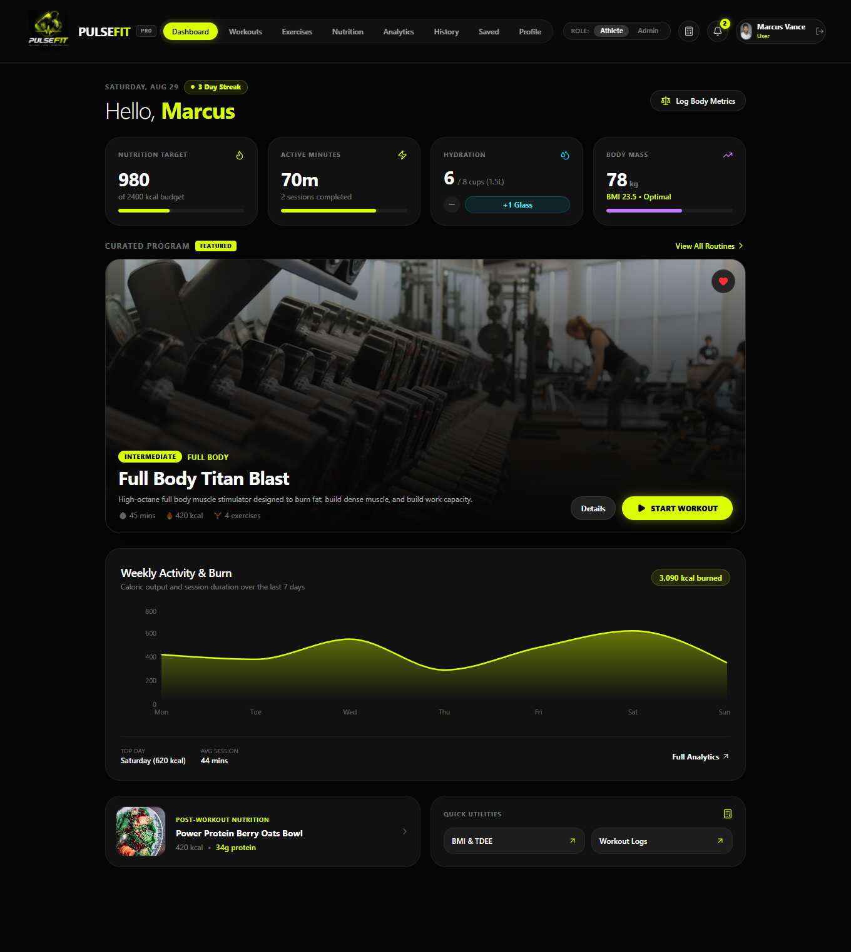
1: PulseFit User Dashboard

9.2 Workout Programs
The Workout Programs section allows users to browse available workout programs. Programs are presented in an organized card-based interface so users can review available routines and select a suitable workout.
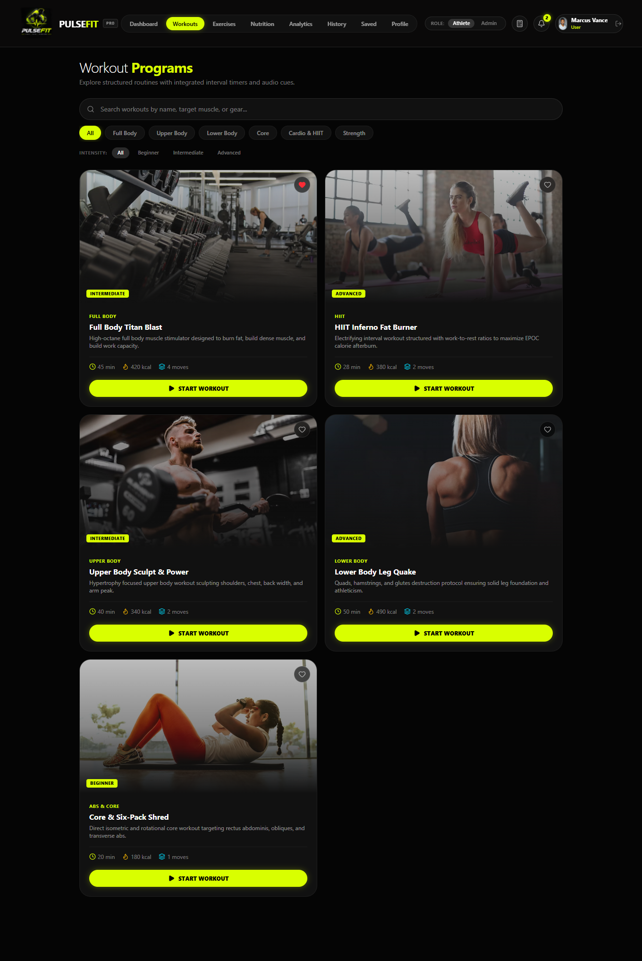
2: PulseFit Workout Programs

9.3 Exercise Library
The Exercise Library provides users with a collection of available exercises. The organized layout makes it easier to browse movements and select exercises for workout activities.
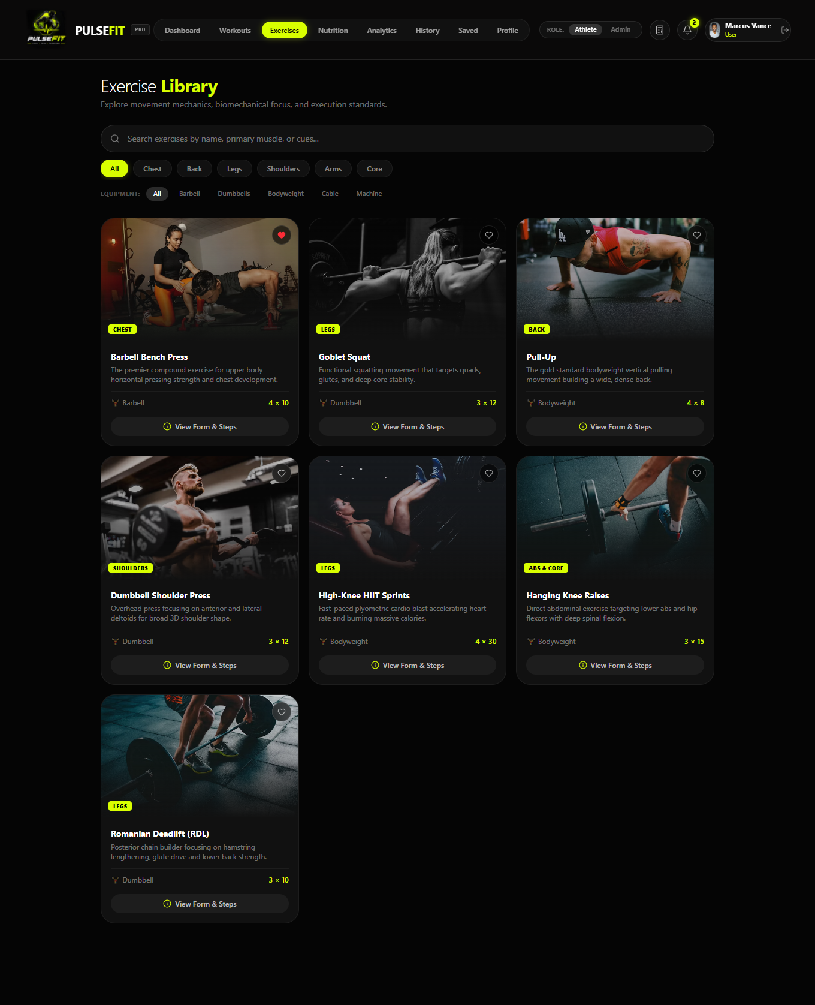
3: PulseFit Exercise Library

9.4 Nutrition and Recipes
The Nutrition section allows users to explore recipes and nutrition information. The interface supports the project's nutrition-tracking functionality and helps users connect meals with their daily fitness goals.
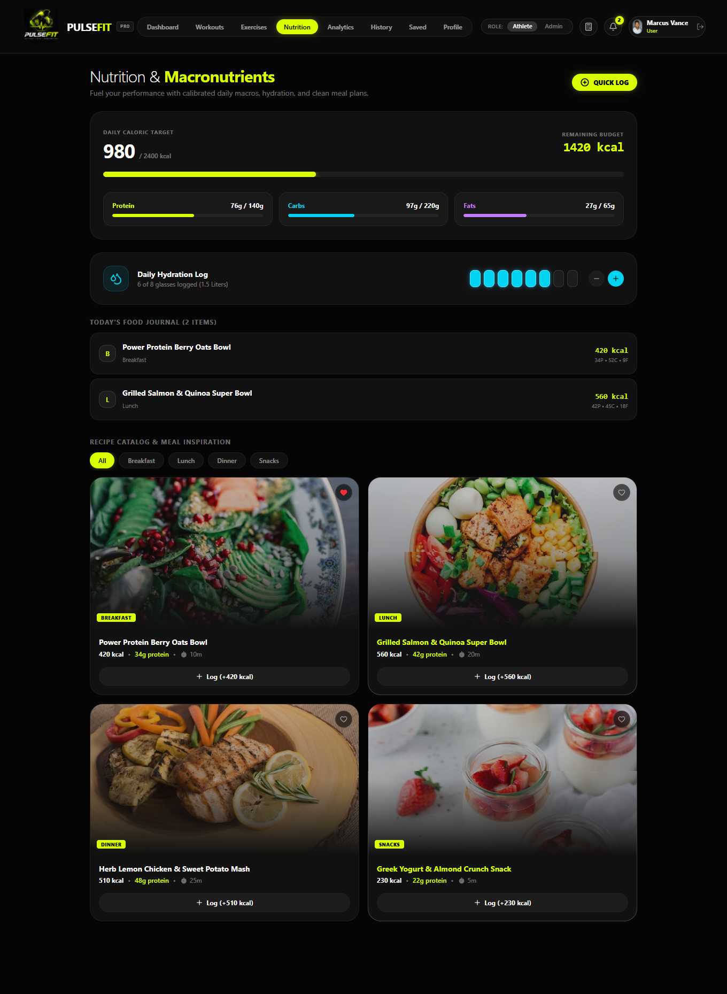
4: PulseFit Nutrition and Recipe Catalog

9.5 Body Analytics
The Body Analytics section presents fitness information through visual analytics. It allows users to review recorded measurements and understand trends in their body-related data over time.
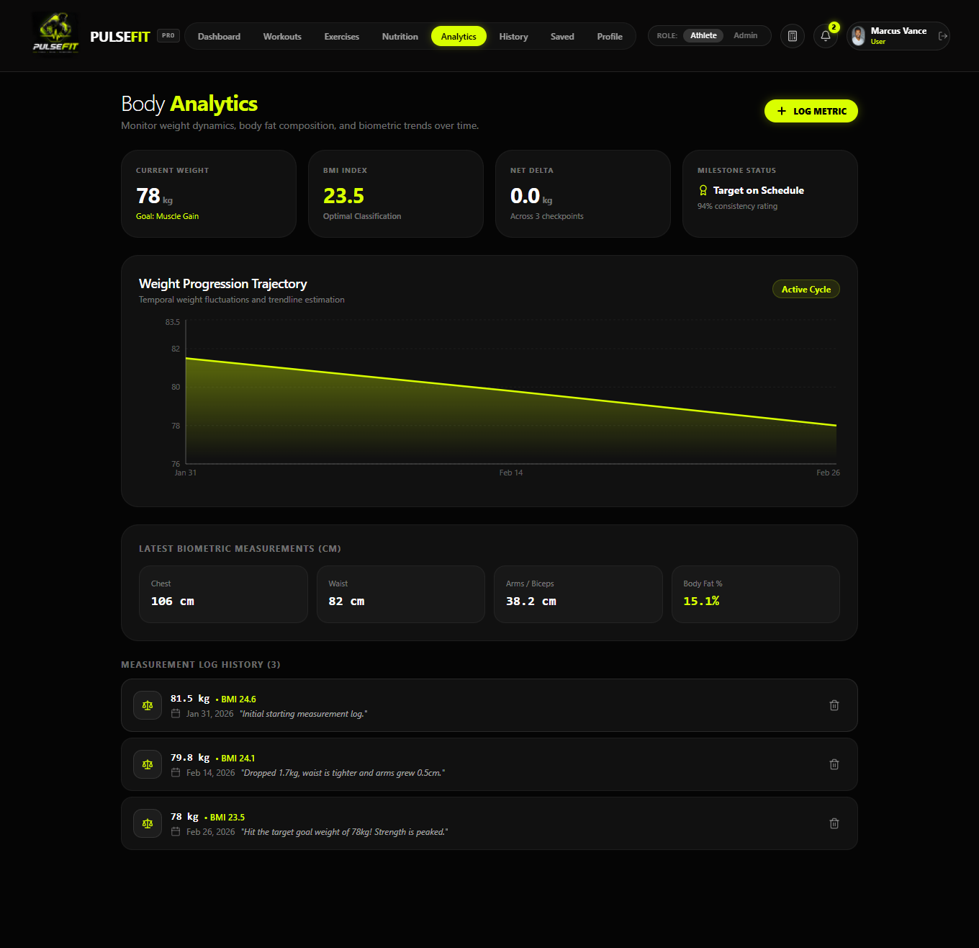
5: PulseFit Body Analytics and Progress

9.6 Workout History
The Workout History interface provides a record of previous workout activities. Users can review completed sessions and related workout statistics from a centralized history page.
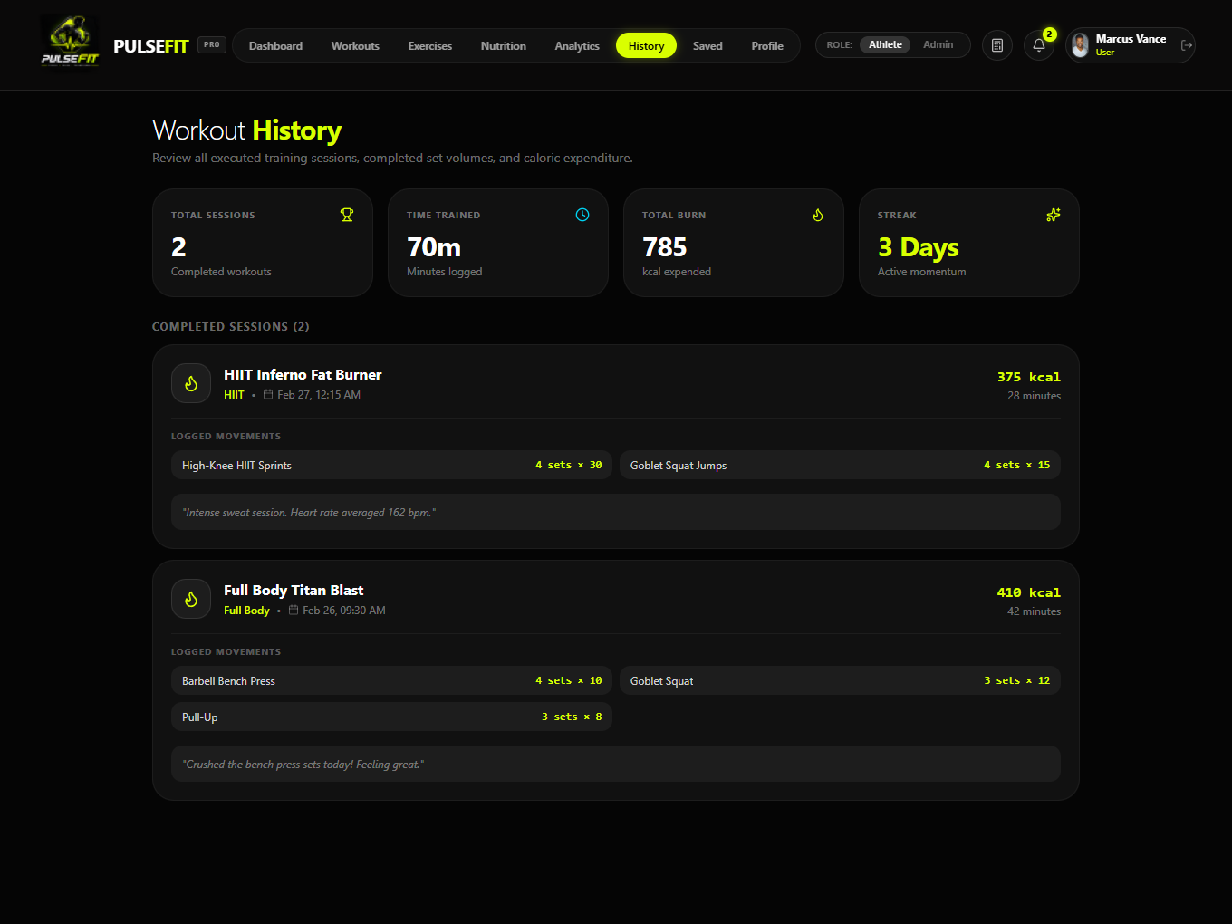
6: PulseFit Workout History

9.7 Saved Bookmarks
The Saved Bookmarks section allows users to save fitness content for later access. This provides a convenient way to return to frequently used workouts and other saved information.
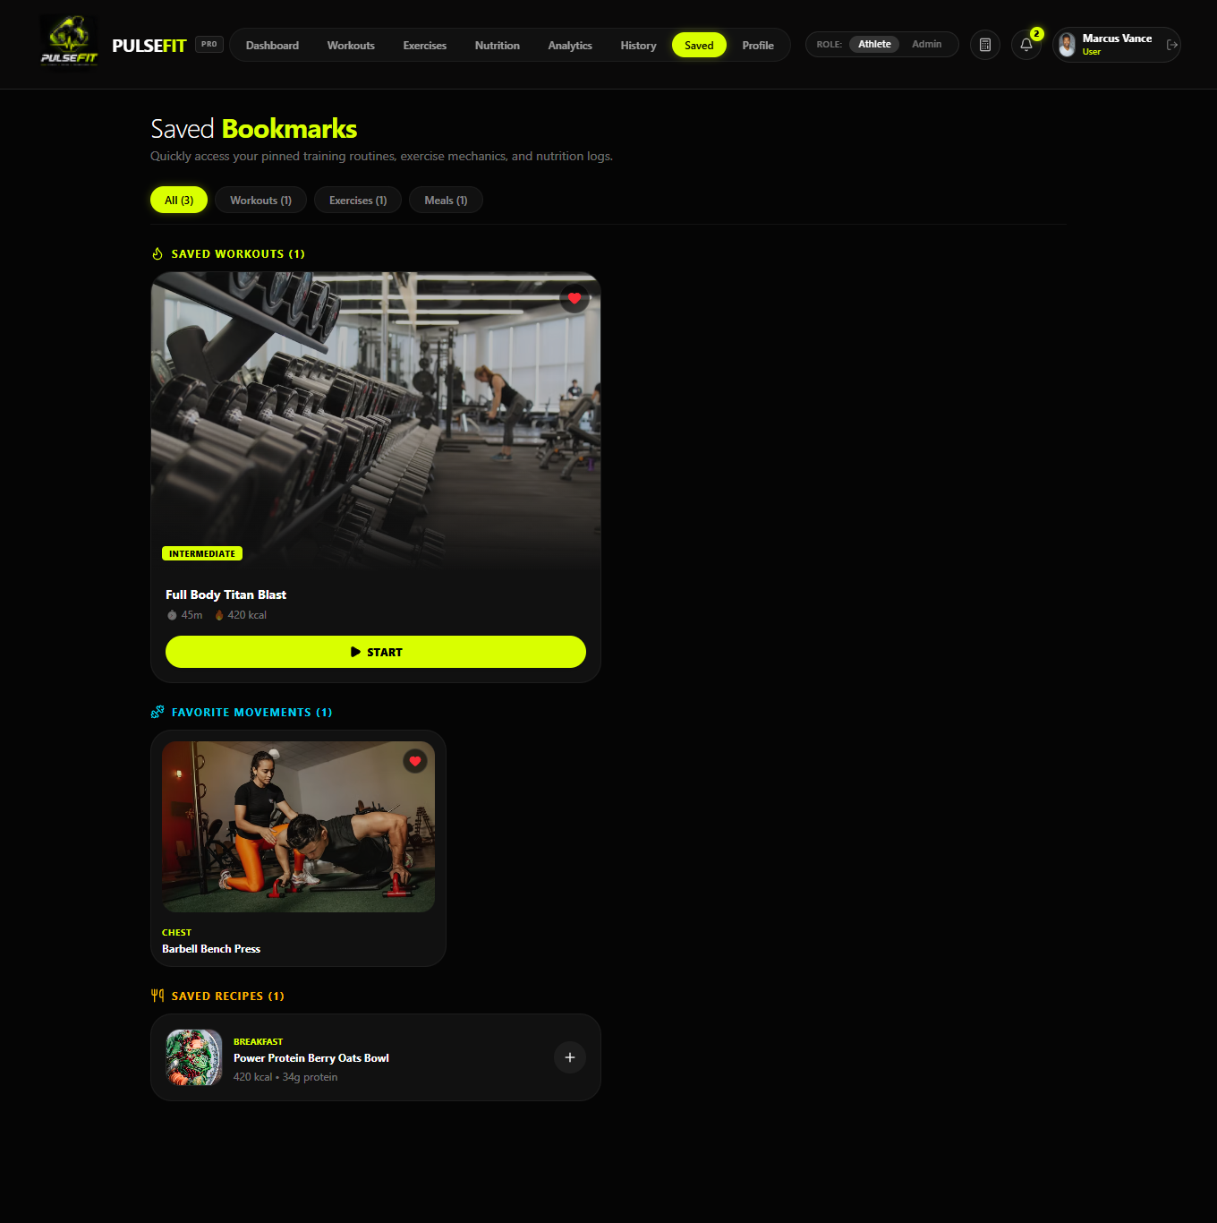
7: PulseFit Saved Bookmarks and Favorites

9.8 User Profile
The user profile interface provides access to personal account information and profile-related controls. It forms part of the personalized user experience within PulseFit.
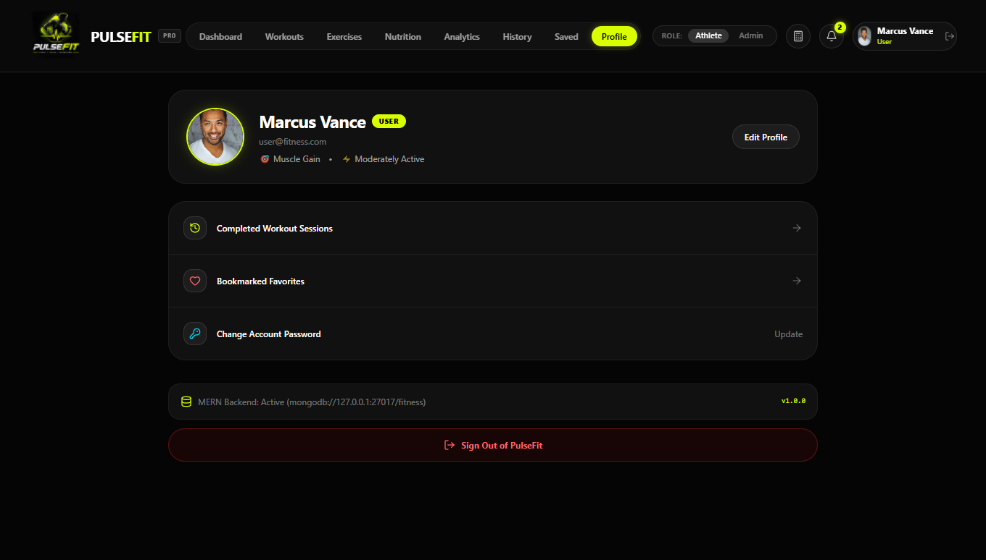
8: PulseFit User Profile

CHAPTER 10 — ADMIN PANEL
The PulseFit administrative panel provides authorized administrators with tools for monitoring application activity and maintaining the fitness content used by the user application.

10.1 Admin Dashboard and Analytics
The Admin Dashboard provides an overview of system activity and analytics. The interface presents statistics and visual information that help administrators monitor users, goals, routines, and completion-related information.
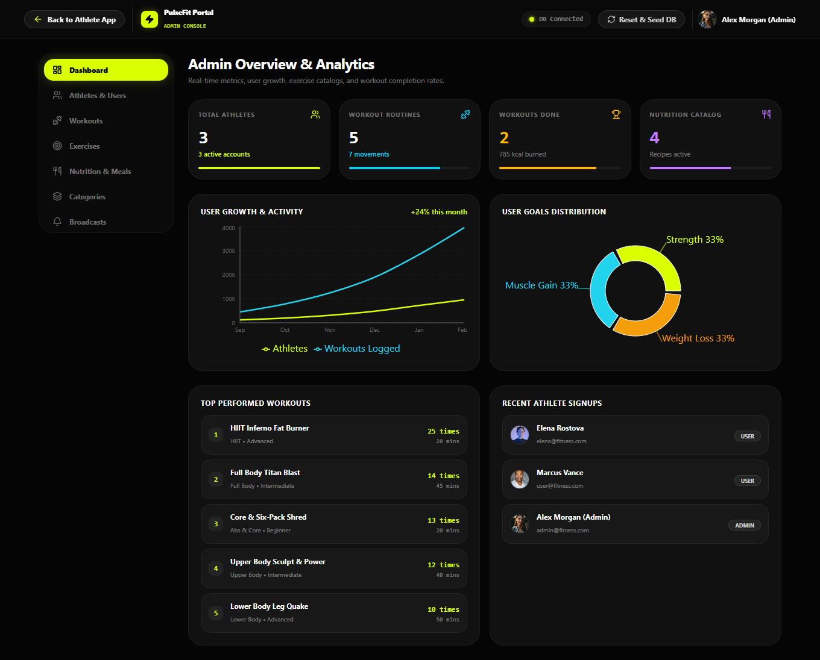
9: PulseFit Admin Dashboard and Analytics

10.2 User Management
The Athletes and Users section allows administrators to view and manage registered accounts. The project supports role-based filtering and account actions such as blocking or unblocking and role changes.
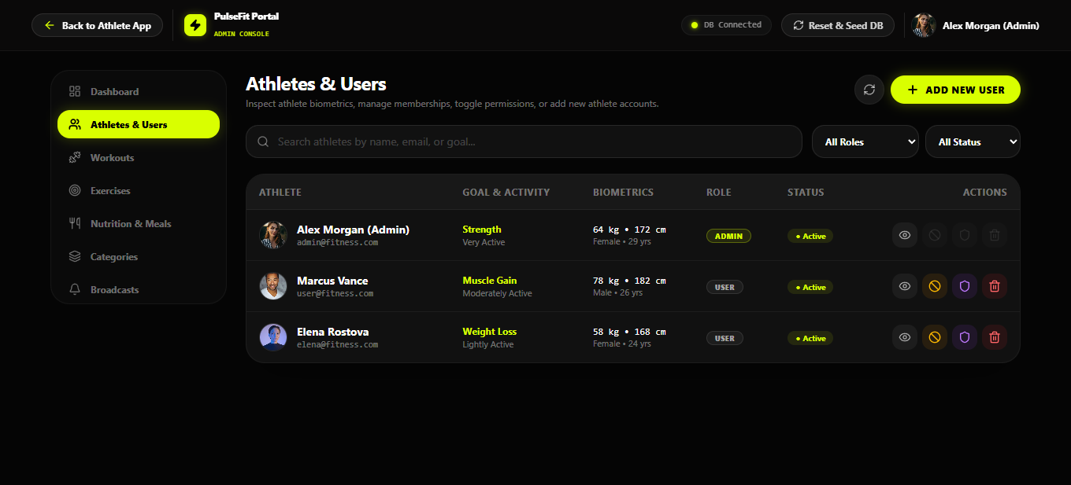
10: PulseFit Admin User Management

10.3 Workout Programs Management
The Workout Programs Catalog allows administrators to maintain the application's workout programs. The project supports creation and editing of workouts with exercise sequences, sets, repetitions, and rest intervals.
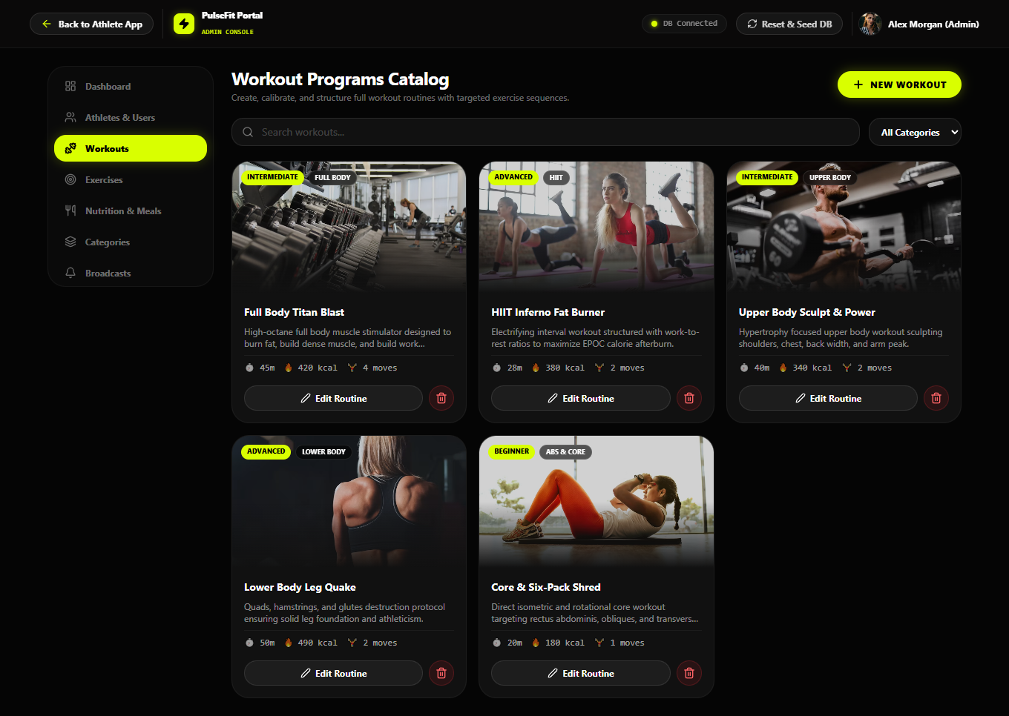
11: PulseFit Admin Workout Programs Catalog

10.4 Exercise Management
The Exercise Library Manager provides administrators with tools to maintain exercise records. The project supports exercise information such as muscle groups, equipment, and form instructions.
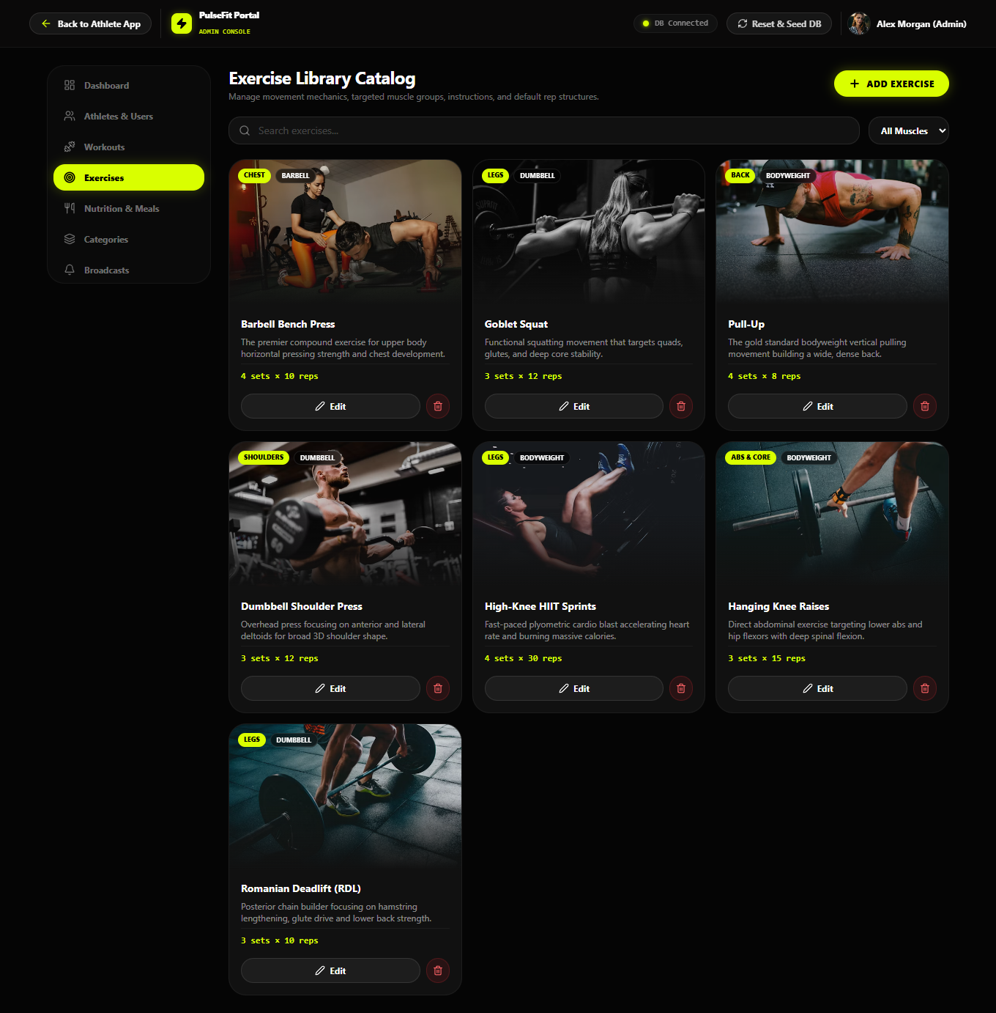
12: PulseFit Admin Exercise Library

10.5 Nutrition and Recipes Management
The Nutrition and Recipes Catalog allows administrators to maintain meal and recipe information, including nutrition-related details and preparation information.
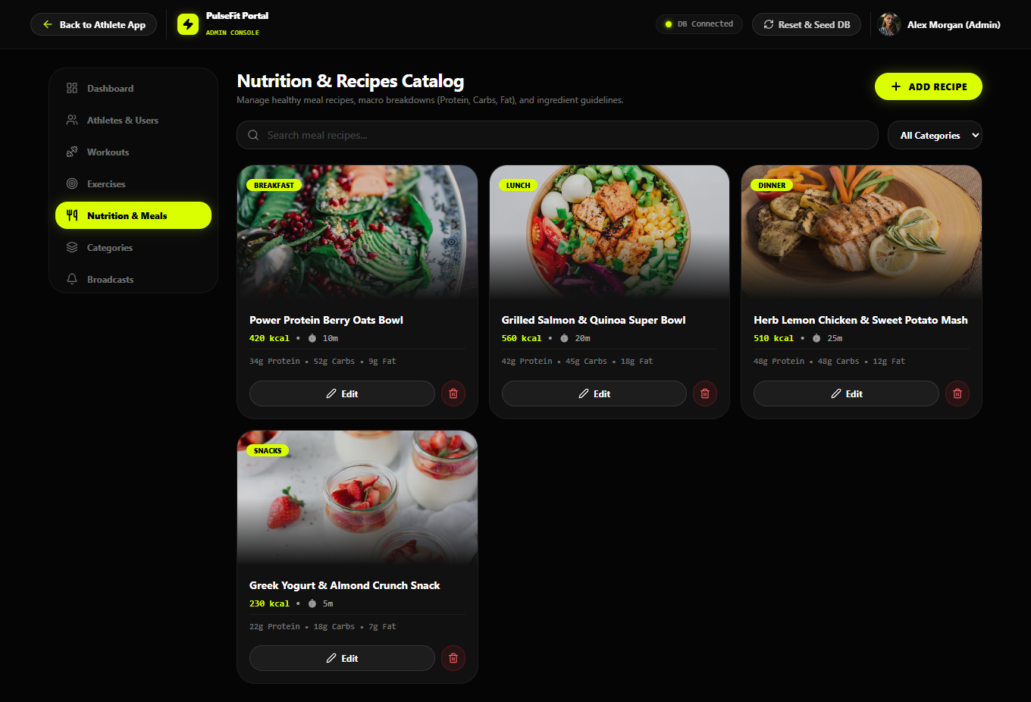
13: PulseFit Admin Nutrition and Recipe Catalog

10.6 Taxonomy and Category Management
The Taxonomy and Category Manager helps administrators organize fitness content. Categories can be maintained for workouts, muscle groups, equipment, and meal-related tags.
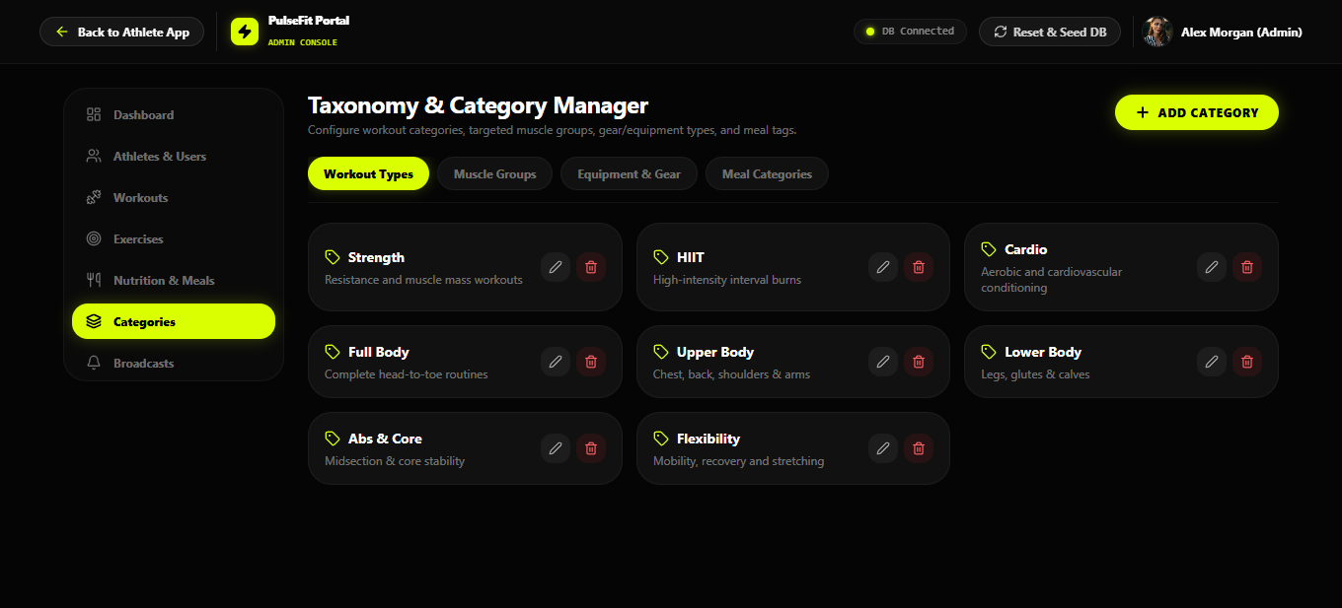
14: PulseFit Admin Taxonomy and Category Manager

10.7 Push Notifications and Broadcasts
The Push Notifications and Broadcasts section allows administrators to prepare system announcements and communicate information to users or targeted roles.
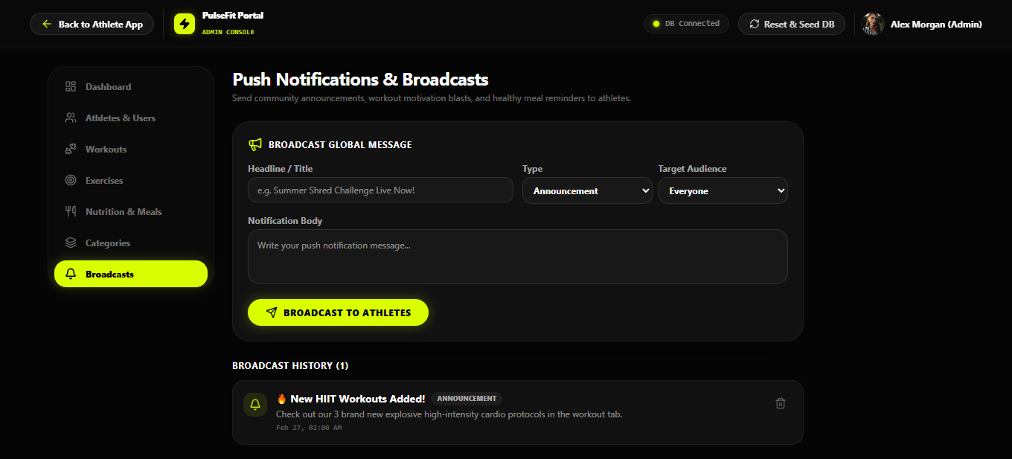
15: PulseFit Admin Push Notifications and Broadcasts

CHAPTER 11 — AUTHENTICATION AND USER SETUP
The following supplied screenshots document the authentication and user setup interfaces. They are included after the main user and administrator screens because they support account access and personalization.

11.1 Authentication Interface
The authentication interface provides the account-access workflow for PulseFit. Users can provide the required account information and access the application after successful authentication.
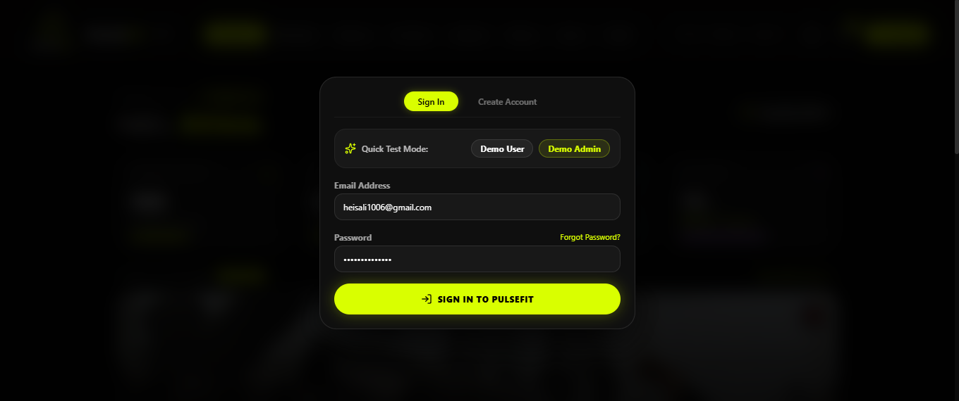
16: PulseFit Authentication Interface

11.2 User Fitness Profile Setup
The fitness profile setup interface collects relevant personal and fitness information that can be used to personalize the application experience and support fitness calculations and progress-related features.
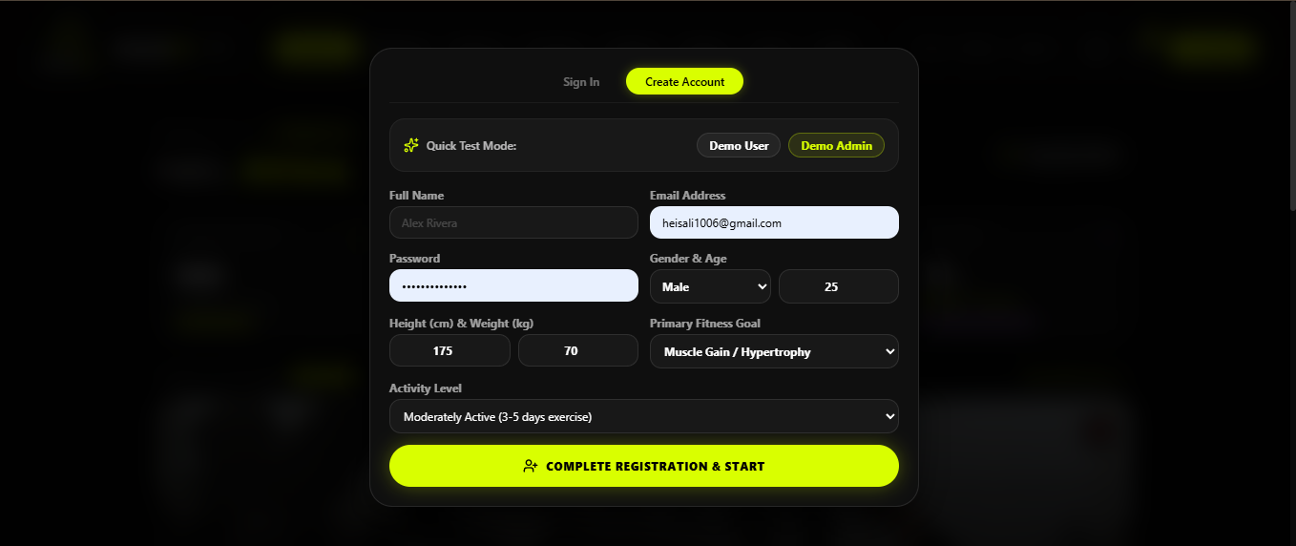
17: PulseFit User Fitness Profile Setup

CHAPTER 12 — TESTING

12.1 Testing Approach
Testing was performed across the major user and administrator workflows to verify that the application functions as expected. The project team reports that the implemented functionality is working. The test cases below summarize the main areas that should be demonstrated during project evaluation.

12.2 Functional Test Cases
ID | Module | Test Case | Expected Result | Status
TC-01 | Registration | Register a new user | A new user account is created successfully. | Pass
TC-02 | Login | Log in using valid credentials | The user is authenticated and reaches the application. | Pass
TC-03 | Login Validation | Use invalid credentials | The system rejects invalid authentication. | Pass
TC-04 | Dashboard | Open the user dashboard | Dashboard information is displayed. | Pass
TC-05 | Workout Programs | Open a workout program | Workout information is displayed. | Pass
TC-06 | Active Workout | Start and complete workout activities | Workout actions and completion flow operate correctly. | Pass
TC-07 | Nutrition | Log a meal | Meal/nutrition information is recorded. | Pass
TC-08 | Progress | Record progress information | Progress information is stored and displayed. | Pass
TC-09 | Calculators | Use fitness calculator | The selected calculation is displayed. | Pass
TC-10 | Notifications | Open notification center | Notifications are displayed. | Pass
TC-11 | Favorites | Save fitness content | Selected content is saved as a favorite. | Pass
TC-12 | Admin Dashboard | Open admin dashboard | Analytics and management overview is displayed. | Pass
TC-13 | Admin Users | Manage users | User management operations work. | Pass
TC-14 | Admin Workouts | Manage workout programs | Workout management operations work. | Pass
TC-15 | Admin Content | Manage exercises, meals and categories | Content-management operations work. | Pass

12.3 Testing Summary
The major workflows represented in the project screenshots were verified as part of the project evaluation process. The team has confirmed that the implemented application functionality is working. For a formal production release, additional automated unit, integration, end-to-end, accessibility, security, and load testing would be recommended.

CHAPTER 13 — INSTALLATION AND CONFIGURATION

13.1 Prerequisites
The project requires Node.js version 18 or higher and a local MongoDB installation or MongoDB Compass. The README specifies MongoDB running locally at mongodb://127.0.0.1:27017.

13.2 Database Configuration
The database used by the project is named “Fitness”. The project contains the collections users, categories, dailylogs, exercises, favorites, meals, notifications, progresses, workouthistories, and workouts.

13.3 Environment Configuration
The project uses environment variables for the application port, MongoDB connection, JWT secret, and token expiration. The actual secret value should not be reused in a public production deployment; it should be replaced with a secure secret.
Example configuration:
PORT=3000
MONGO_URI=mongodb://127.0.0.1:27017/fitness
JWT_SECRET=<your-secure-secret>
JWT_EXPIRES_IN=7d

13.4 Install Dependencies
Open the project folder in a terminal and install the required packages:
npm install

13.5 Seed the Database
The project provides a seed command for populating the database with default fitness records:
npm run seed

13.6 Run the Application
Start the development application using:
npm run dev
The project README specifies that the application can then be opened at http://localhost:3000.

13.7 Demo Accounts
The supplied README contains demo accounts for evaluation. These credentials are intended for the project demonstration environment and should be changed or removed before any public production deployment.
Role | Email | Password
Regular Athlete User | user@fitness.com | Password123!
Administrator | admin@fitness.com | Admin123!

CHAPTER 14 — USER GUIDE

14.1 Registering an Account
Open the PulseFit authentication interface and provide the required registration information. After successful registration, the account can be used to access the user application.

14.2 Logging In
Enter the registered account credentials in the login interface. After successful authentication, the user is directed to the main application experience.

14.3 Using the Dashboard
Use the dashboard to review daily fitness information, activity, calories, hydration, BMI information, progress, and recommended content.

14.4 Starting a Workout
Open Workout Programs, select an available routine, and start the workout. During an active workout, exercises and sets can be completed while rest intervals are managed by the application.

14.5 Recording Nutrition
Open the Nutrition section to browse recipes or record meal information. Nutrition data can be used to monitor calories and macronutrients.

14.6 Tracking Progress
Open Body Analytics or the progress area to review recorded measurements and historical trends.

14.7 Using Fitness Calculators
Use the calculator features to obtain BMI, BMR, TDEE, calorie-target, and heart-rate training-zone values.

14.8 Managing Favorites
Bookmark useful workouts, exercises, and recipes so they can be accessed again through the saved/favorites area.

14.9 Viewing Notifications
Open the notification center to review announcements, workout tips, hydration reminders, and other updates.

CHAPTER 15 — ADMIN GUIDE

15.1 Admin Login
Use the administrator account to access the administrative interface. Administrative access should only be provided to authorized personnel.

15.2 Admin Dashboard
Review system analytics and performance information such as user activity, goals, popular routines, and completion statistics.

15.3 User Management
Open Athletes & Users to review registered accounts and use the available account-management operations.

15.4 Workout Management
Use the Workout Programs Catalog to create or edit workout programs and maintain exercise sequences, sets, repetitions, and rest intervals.

15.5 Exercise Management
Use the Exercise Library Manager to maintain exercise records, including movement, muscle-group, equipment, and form information.

15.6 Meal Management
Use the Nutrition & Recipes Catalog to maintain meal and recipe records and their nutritional information.

15.7 Category Management
Use the Taxonomy & Category Manager to maintain workout categories, muscle groups, equipment, and meal tags.

15.8 Notifications
Use Push Notifications & Broadcasts to prepare announcements for all athletes or targeted roles.

15.9 Database Reset and Seeding
The project supports database population through the npm run seed command and provides an administrative database reset/re-seed facility for development and demonstration.

CHAPTER 16 — LIMITATIONS
The current PulseFit project is focused on fitness tracking and management through the implemented MERN application. Its scope is defined by the supplied project requirements and the functionality described in the project README.
Advanced external integrations such as wearable-device synchronization, advanced AI coaching, cloud infrastructure, and a dedicated native mobile application are not treated as core components of the current project and can be considered future enhancements.
The application's local development setup also depends on correctly configured Node.js and MongoDB services. Deployment to a public environment would require additional production configuration, security hardening, monitoring, and backup procedures.

CHAPTER 17 — FUTURE ENHANCEMENTS

17.1 Wearable Device Integration
Future versions could integrate smartwatches and fitness bands to automatically collect activity, heart-rate, and workout information.

17.2 AI-Based Fitness Recommendations
Artificial intelligence could be added to provide personalized workout and nutrition suggestions based on user goals and recorded activity.

17.3 Cloud Deployment
The application could be deployed to cloud infrastructure so that users can securely access their fitness information from different devices and locations.

17.4 Advanced Analytics
Additional analytics could provide deeper insights into workout performance, nutrition patterns, and long-term progress.

17.5 Dedicated Mobile Application
A dedicated Android or iOS client could be developed using the existing backend APIs.

17.6 Social and Community Features
Future versions could add challenges, friend connections, achievement sharing, and other community-oriented features.

CHAPTER 18 — CONCLUSION
PulseFit is a full-stack fitness management application developed using the MERN stack. It combines workout programs, exercise information, nutrition tracking, progress and analytics, fitness calculations, notifications, favorites, and personalized dashboard functionality into one application.
The project also provides a dedicated administrative experience for managing users, workout programs, exercises, meals, categories, notifications, and database data. This gives the project both a complete user-facing side and a management side.
The development of PulseFit demonstrates practical understanding of frontend development, backend API development, database integration, authentication, responsive interface design, data visualization, and software documentation. The project provides a foundation that can be expanded through wearable integrations, cloud deployment, advanced analytics, AI-assisted recommendations, and mobile applications.

REFERENCES
- Aptech Learning — MERN Fitness Tracker / Fitness Tracker E-Project Requirements Document.
- PulseFit project README.md supplied with the project source files.
- MongoDB documentation and project database configuration.
- React.js documentation and project frontend implementation.
- Node.js and Express.js documentation and project backend implementation.
- Tailwind CSS documentation and project styling implementation.
- TypeScript documentation and project codebase.
- JSON Web Token (JWT) documentation and project authentication implementation.

